Forest Fire robotic vehicle
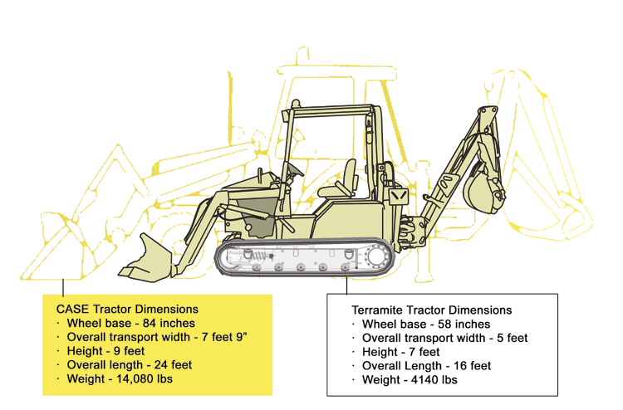
Darken the large machine outline
Change the Terramite Name to: Commercial Tractor.

Change the CASE name to: Large Tractor
Current problem: Forest Fire Teams are required to work in an environment where they are exposed to an ever-changing dangerous situation. There is a need for equipment to support the movement of debris and rubble to minimize and/or control the fire. Current equipment that is capable of doing this is very large and cannot be transported into remote areas, plus such machines are dangerous to use in mountainous areas.

Current Solution: Adaptation of a COTS backhoe/loader to that of a tracked design minimizes the danger to the operator by placing him away from the fire and the vehicle. Helicopter or standard size pickup truck vehicles can provide transportation. In addition, the design can be quickly modified with new and existing firefighting systems that may include water cannon, fire suppressant systems and cameras.

Benefit: Using such a design gives Fire Fighting Teams the mechanical tool to equal the work capacity of over 10 men. In addition, integration with nuclear, biological, chemical (NBC) detection systems allows this design to be used to support Homeland Security. Specifically, to remove vehicles and/or debris that may contain explosives or are burning from adjacent areas and to help extinguish fires for airport and transportation needs. Such a design will also support Army units responsible for fighting fires that may be caused by accidents, explosions, or bombs.

Group | Use | Availability | Cross Reference | Technical Reference | Price
Military | Primary | 180 days | A1, A2, A3, A3a, A4, A5, A7, A8 |  | $75,000
Construction | Secondary | 180 days
Industrial Applications | Primary | 180 days
Homeland Security | Primary | 180 days

U.S. Patent Nos. 7,264,354, 7,275,459, 7,565,941, and Patents Pending.

